COPA amplifier tests summary
date: 18/06/2024
Place: PTB

Authors: RI - LP
version: V01

Two indentical boards were built by CTU and delivered to PTB:
1) Board #1
2) Board #2

Tests on board #2:
a) Sweeps: -Gain, Phase, FFT, THD+N and SINAD

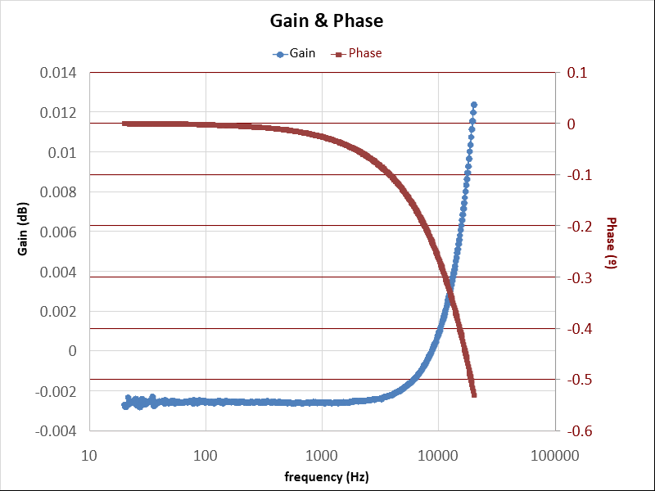

Figure XX. Gain and Phase Board_2 20 Hz to 20 kHz, BW DC-90 kHz.

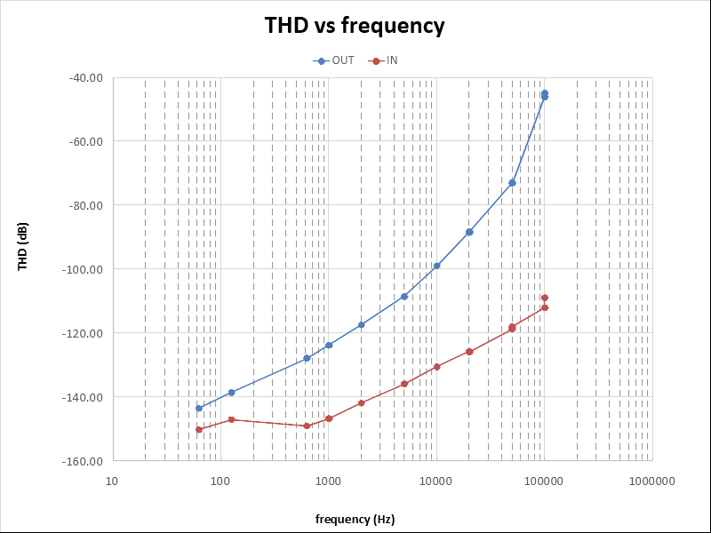
b) THD:

 | fo (Hz) | THD (dB)
 | 62.5 | -143.52
 | 125 | -138.58
 | 625 | -127.85
 | 1000 | -123.80
Board_2 | 2000 | -117.42
 | 5000 | -108.54
 | 10002 | -98.97
 | 20006 | -88.52
 | 20006 | -88.33
 | 49986 | -73.00
 | 49985 | -73.09
 | 100026 | -46.16
 | 100026 | -45.01

Figure XX. Total Harmonic Distortion Board_2

Tests on Board_#1:
Board #1 was modified from its original version. Changes: i) the gain resistors R7 and R8 were removed, and the boostrap circuit was disconnected and its input grounded.

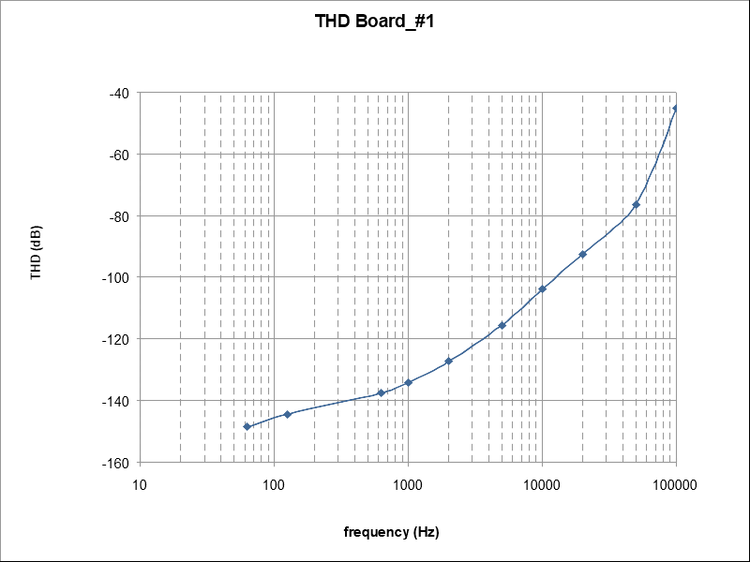
Starting date: 13/06/2024
a ) Total Harmonic Distortion

 | fo (Hz) | THD (dB)
 | 62.5 | -148.51
 | 125 | -144.37
 | 625 | -137.56
 | 1000 | -134.14
Board_1 | 2000 | -127.30
 | 5000 | -115.49
 | 10000 | -103.88
 | 20000 | -92.43
 | 50000 | -76.49
 | 100000 | -45.14

Figure XX. Total Harmonic Distortion Board_1

There was a improvement on the performance as it can be seen on the following figure were the THD are compared.

Total Harmonic distortion comparison Board_#1 and Board_#2
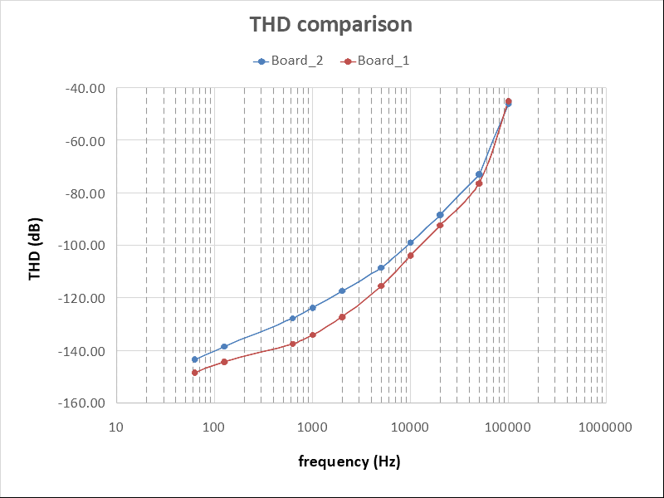
fo (Hz) | diff B2-B1 (dB)
62.5 | 4.999
125 | 5.783
625 | 9.708
1000 | 10.343
2000 | 9.885
5000 | 6.947
10000 | 4.911
20000 | 3.913
50000 | 3.488
100000 | -1.021

Figure XX. Total harmonic distortion comparison

b) Total Harmonic Distortion vs Input Amplitude. Decreasing the input amplitude, starting from the full scale (7.071 V rms) down to the value were the THD is less or equal to -120 dB
At signal frequencies above 20 kHz is not possible to get a THD < -120 dB
for frequencies in the range of 62.5 Hz up to 2 kHz, not shown in the figure, the THD is lower than -120 dB.

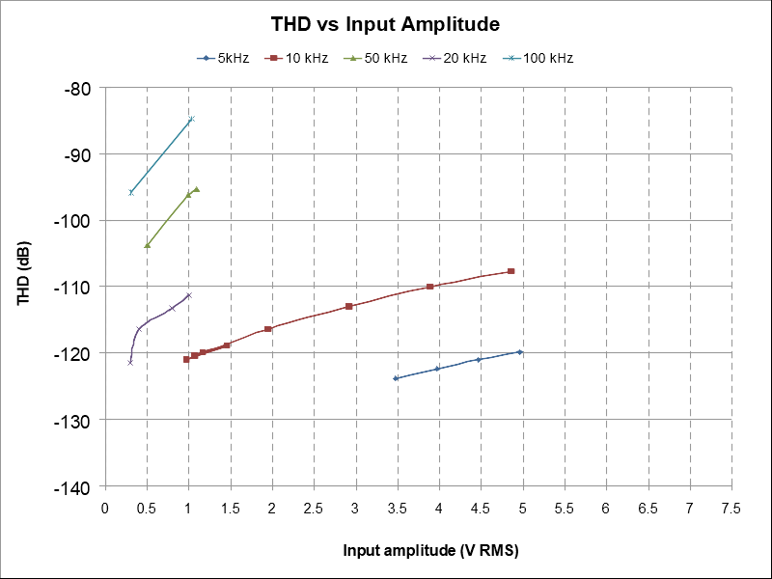

full scale amplitude

Figure XX. Total Harmonic Distortion versus input signal amplitude for frequencies in the range 5 kHz up to 100 kHz

c) Sweep Gain, Phase
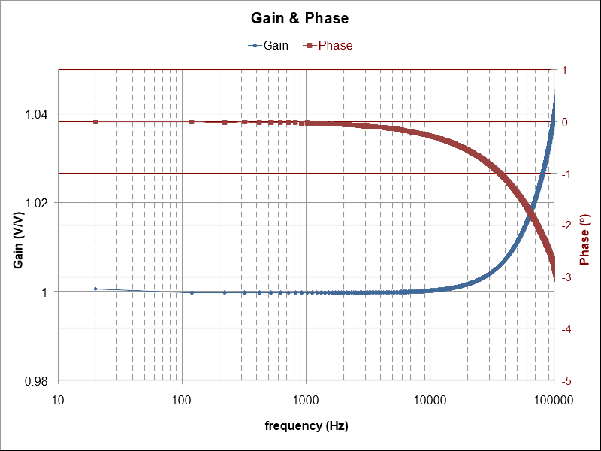
Sweep from 20 Hz to 200 kHz, sampler BW DC - 1MHz, Sampling Rate: 2.496 MHz, Input amplitude: 1 V RMS and 7.071 V RMS (FS: full scale)
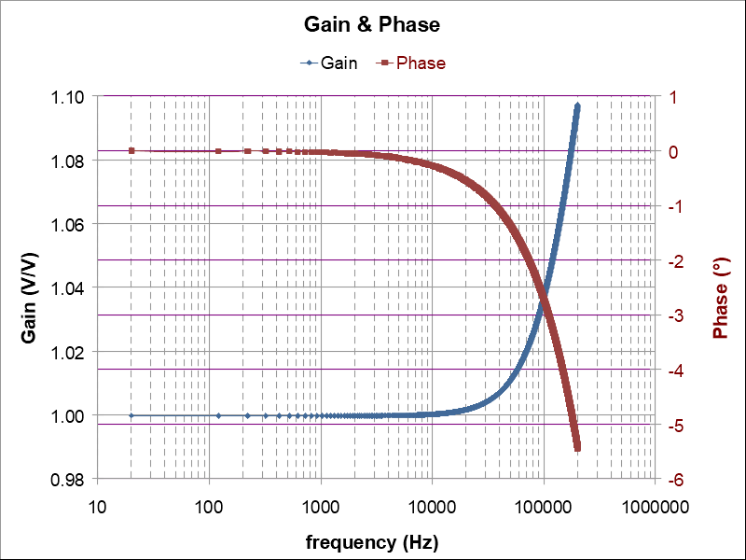
Figure XX. Board #1 Gain and Phase at 1 V RMS Figure XX. Board #1 Gain and Phase at full scale

d ) Noise.
i) Voltage noise.
Setup: The COPA amplifer input was shorted and the output connected to a pre-amplifier (PTB PA3 Ultra Low Noise AC pre-amplifier) running both on batteries. The PTB PA3 internal batteries and the COPA powered by a +/-12 V battery pack. The PA3 output was connected to the AD CH2 sampler. The AP software was configure to sample the data at 192 kHz (BWDC 90 kHz), averaging 64 windows of 1.2 M data points with a rectangular windows (no window function on the software).

AP nominal gain = x60, measured gain = x59.2
Figure XX shows the Amplitude Spectrum Density of the measured signal divided by the PA3 gain factor.
Noise level @ 1 kHz was determined as 3.9 nV/ Hz^{½}

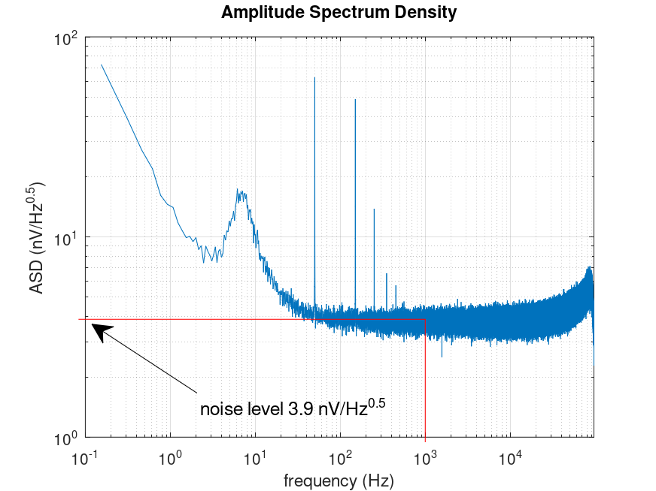

Figure XX. Board #1. Amplitude Spectrum Density over a 64 averaged spectra (1.2M window length)

e) Spectrum at different loads values. In order to verify the load influence on the COPA amplifier spectrum, two spectras were acquaried, with the AP sampler at 100 kΩ and 600 Ω.
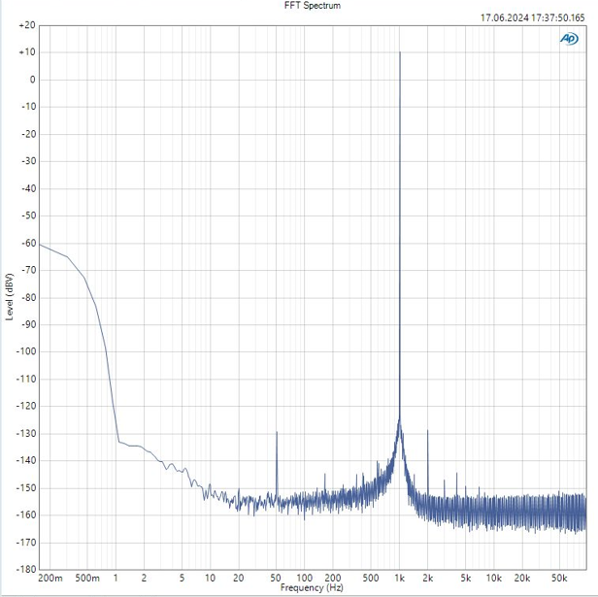
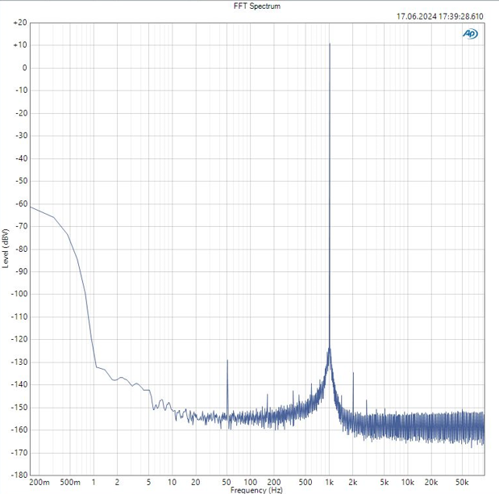
3.5 V RMS @ 1 kHz, 600 Ω. 3.5 V RMS @ 1 kHz, 100 kΩ.

3.5 V RMS @ 1 kHz, 600 Ω. 3.5 V RMS @ 1 kHz, 100 kΩ.

 |  | 600 OHM LOAD |  | 100 kOHM LOAD
 | freq (Hz) | Amp (dBV) | Amp (V) | Amp (dBV) | Amp (V) | Delta (V)
fo | 1.0002E+03 | -0.82809 | 0.909066 | -0.12816 | 0.985353 | 0.07629
2fo | 2.0002E+03 | -149.05 | 3.53E-08 | -144.15 | 6.20E-08 | 2.67E-08
3fo | 3.0003E+03 | -159 | 1.12E-08 | -156.63 | 1.47E-08 | 3.52E-09
Table for 1 V rms at 1 kHz
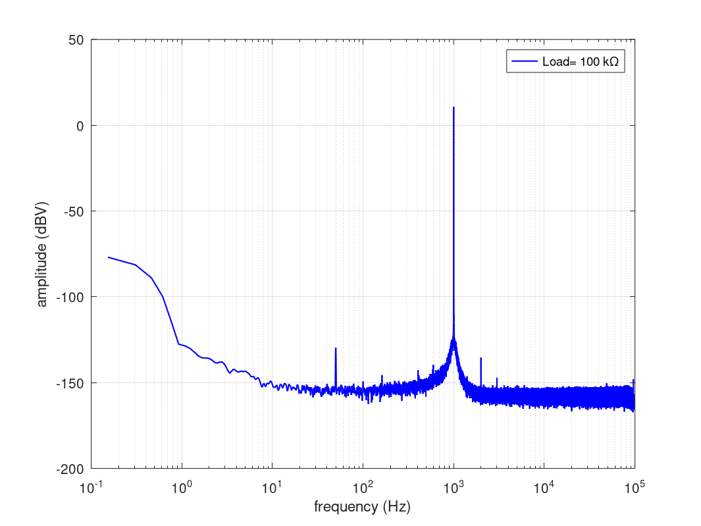
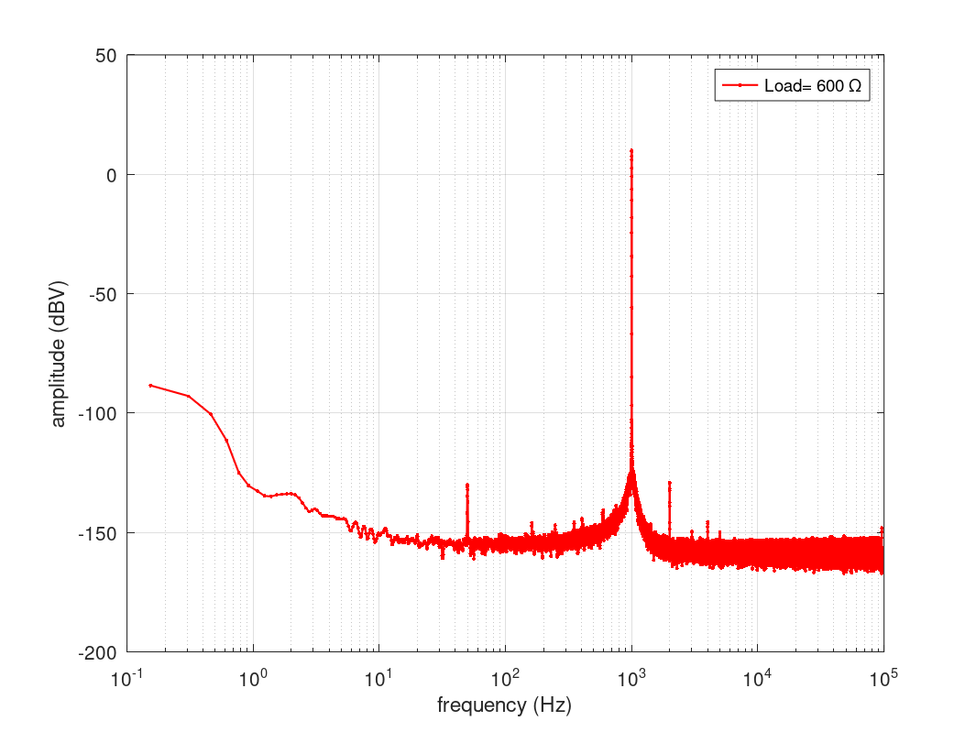

 |  | 600 OHM LOAD |  | 100 kOHM LOAD
 | freq (Hz) | Amp (dBV) | Amp (V) | Amp (dBV) | Amp (V) | Delta (V)
fo | 1000.154 | 10.049 | 3.180168 | 10.748 | 3.446672 | 0.2665
2fo | 2000.154 | -128.985 | 3.55E-07 | -135.39 | 1.70E-07 | -1.85E-07
3fo | 3000.308 | -149.577 | 3.32E-08 | -147.197 | 4.37E-08 | 1.05E-08
4fo | 4000.462 | -145.531 | 5.29E-08 | -154.121 | 1.97E-08 | -3.32E-08
Table for 3.5 V rms at 1 kHz

f) Input Impedance.
Adding a 100 MΩ resistor in series with the COPA the ratio beween the input and output voltage was measured with a AP using the sweep function, from a frequency range of 20 Hz to 20 kHz, input voltage 5 V RMS.

Zi@20 Hz = 0.92 GΩ
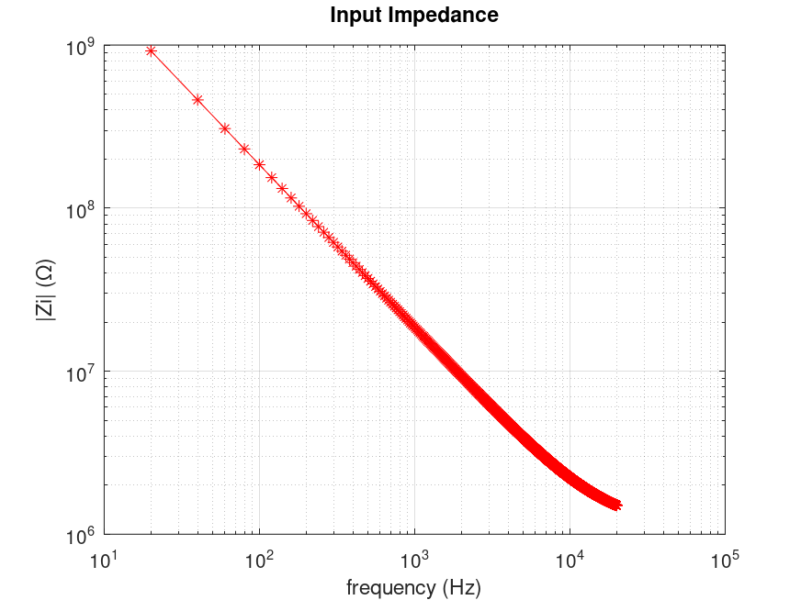

Figure XX. Input Impedance

SIMULATION Results
a) Gain and Phase LTSPICE
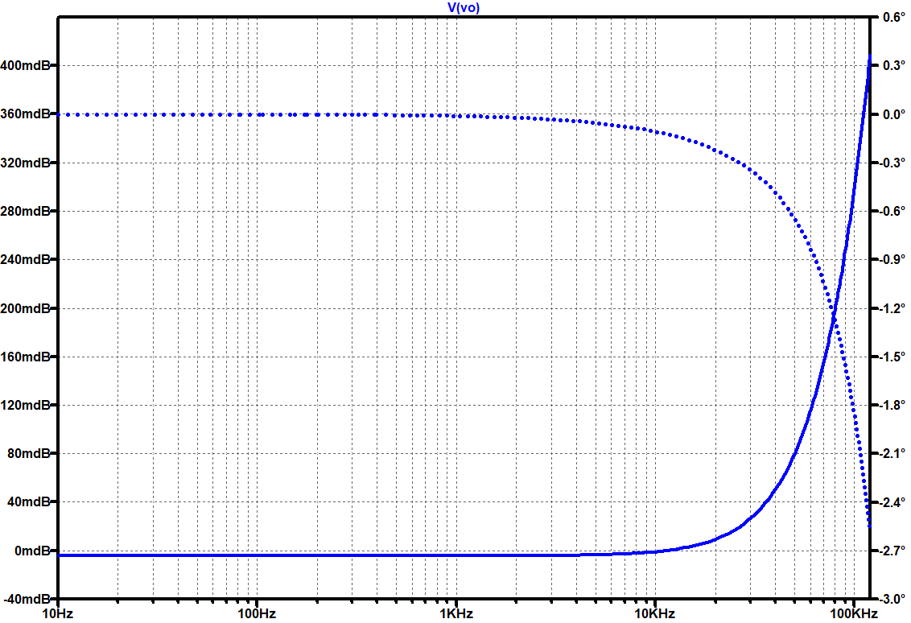

b) Voltage input noise
